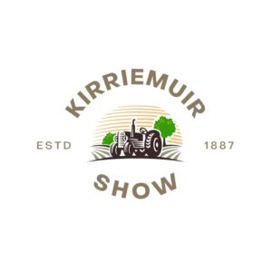
Kirriemuir District Agricultural Association

Sponsorship Packages 2024

PACKAGE | NAME | DESCRIPTION | COST
Package 1 | Main Sponsor | - 8 Entry Tickets  - 8 Lunches  - Hospitality VIP access  - Invitation to Fundraising Event  - Tradestand Space  - Space for Ringside Banner  - Sponsorship Branding on any Advertising  - Website front page listing/Catalogue Premium Space  - Full page Advert in Catalogue | £1000
Package 2 | Key Sponsor | - 4 Entry Tickets  - Hospitality VIP Access till 12noon  - Tradestand space Negotiable  - Space for Ringside Banner  - Listed as a Sponsor on Website and Catalogue  - Full page Advert in Catalogue | £400
Package 3 | Sponsor | - 3 Entry Tickets  - Hospitality VIP Access until 12noon  - Listed as Sponsor on Website and Catalogue  - ½ Page Advert in Catalogue | £300
Package 4 | Section Sponsor | - 2 Entry Tickets  - Hospitality VIP Access until 12noon  - ½ page Catalogue Advert | £200
Package 5 | Donor | - 2 Entry Tickets  - Listed as a Supporter on Website and Catalogue | £60
Package 6 | Advertiser | - Full Page Advert in Catalogue  - ½ Page Advert in Catalogue | £100  £65
Package 7 | Show Day Advertiser | - Space for Ringside Banner | £80

